**FINAL EXAM PROJECT**

**Tic-Tac-Toe Game in C**

**Student:** Duong Thai Huy

**Professor:** Dr. Ho Quoc Dung

**Class:** Cyber Security and Data Science – University of Turku

**Student number:** 523666

1. **WHAT IS TIC TAC TOE GAME?**

Tic Tac Toe is an integral part of our childhood memories. It is a fun game consisting of two players who battle each other using Xs and Os. But did you know that this game can be a good C project? If you program it correctly, you can have fun playing it on your PC with your friends again.

This project explains how to create a simple game of Tic Tac Toe using C programming language. This article contains a simple source code of the Tic Tac Toe game for two players with proper documentation.

1. **RULES OF THE GAMES**
2. **General**

* Tic-tac-toe is a game where two players X and O fill the hash (#) shaped box (consist of two vertical lines crossing two horizontal lines) with their alternate turns. The player who first fills the box with 3Xs or 3Os in a horizontal, vertical, or diagonal manner will win the game.
* In some cases, when none of the players succeeds in filling the boxes horizontally, vertically, or diagonally with 3Xs or 3Os, then the game will be considered to be a draw.

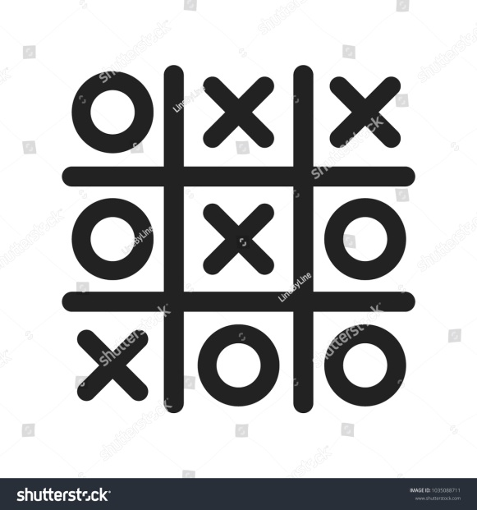

1. **Newell and Simon's 1972 tic-tac-toe program**

A player can play a perfect play of tic-tac-toe (to win or, at least, draw) if they choose the first available move from the following list, each turn, as used in Newell and Simon's 1972 tic-tac-toe program:

1. Win: If the player has two in a row, they can place a third to get three in a row.
2. Block: If the opponent has two in a row, the player must play the third themselves to block the opponent.
3. Fork: Create an opportunity where the player has two threats to win (two non-blocked lines of 2).
4. Blocking an opponent's fork:Option 1: The player should create two in a row to force the opponent into defending, as long as it doesn't result in them creating a fork. For example, if "X" has two opposite corners and "O" has the center, "O" must not play a corner in order to win. (Playing a corner in this scenario creates a fork for "X" to win.)Option 2: If there is a configuration where the opponent can fork, the player should block that fork.
5. Center: A player marks the center. (If it is the first move of the game, playing on a corner gives the second player more opportunities to make a mistake and may therefore be the better choice; however, it makes no difference between perfect players.)
6. Opposite corner: If the opponent is in the corner, the player plays the opposite corner.
7. Empty corner: The player plays in a corner square.
8. Empty side: The player plays in a middle square on any of the 4 sides.
9. **IMPLEMENTATION IN C LANGUAGE**

In order to create a Tic Tac Toe game in C language, we can create a two-player using Array, Function, and True-False condition.

1. **Importing the in-build libraries in C**

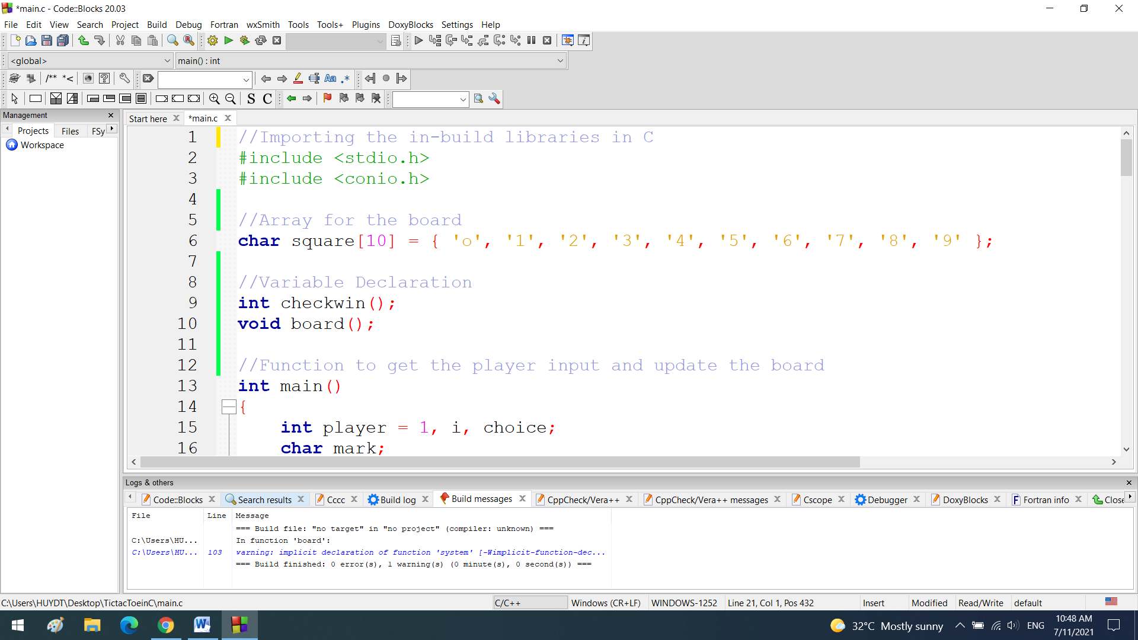

1. **Array for the board and Variable Declaration**

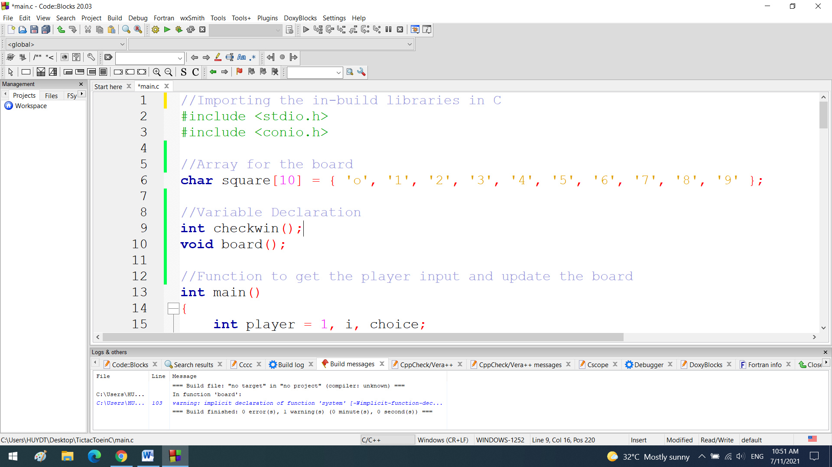

1. **Function to draw board of game with players mark**

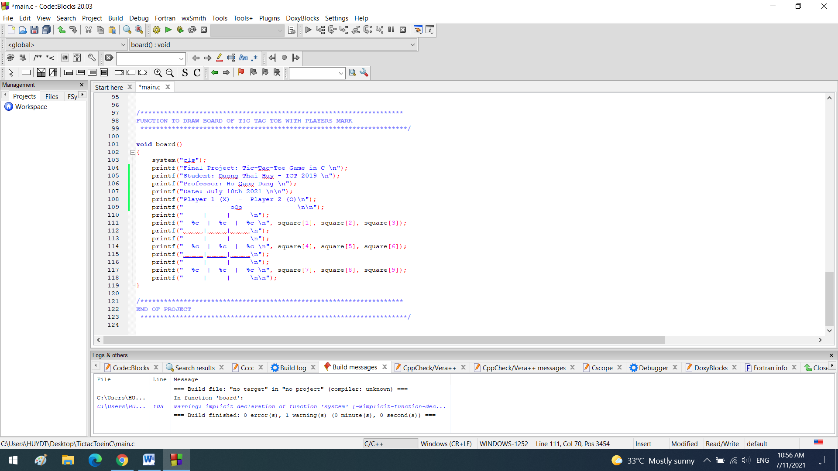

1. **Function to get the player input and update the board**

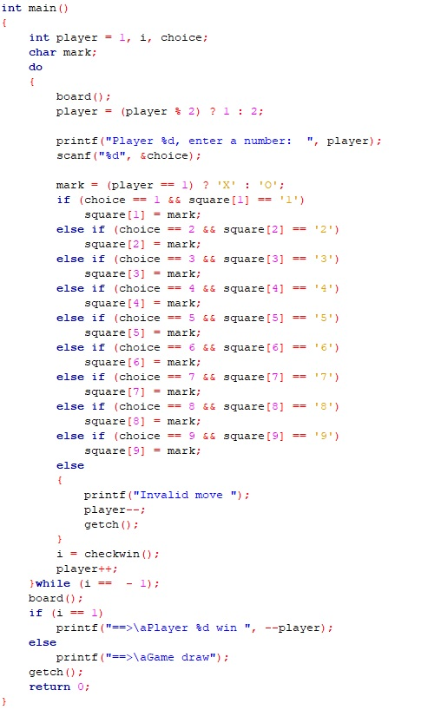

1. **Function to return game status:**

* 1 for game is over
* -1 for game in progress
* 0 for game is over and no result.

